**COMSATS UNIVERSTY ISLAMABAD**

**ATTOCK CAMPUS**

Program: BS(SE)

**Name**:

Areeba Fatima

**Reg. No**:

SP23-BSE-022

**Course**:

DS Theory

**Assignment No**:

01

**Date:**

24 September 2024

**Submitted to**:

Sir Kamran

To implement the task management system using a singly linked list in C++, here’s how you can approach the problem:

**1:Structure of the Node:**

Each task will be represented by a node in the singly linked list. Each node will contain:A unique task ID (integer)A task description (string)A priority level (integer)

A pointer to the next node in the list.

**2:Output**:

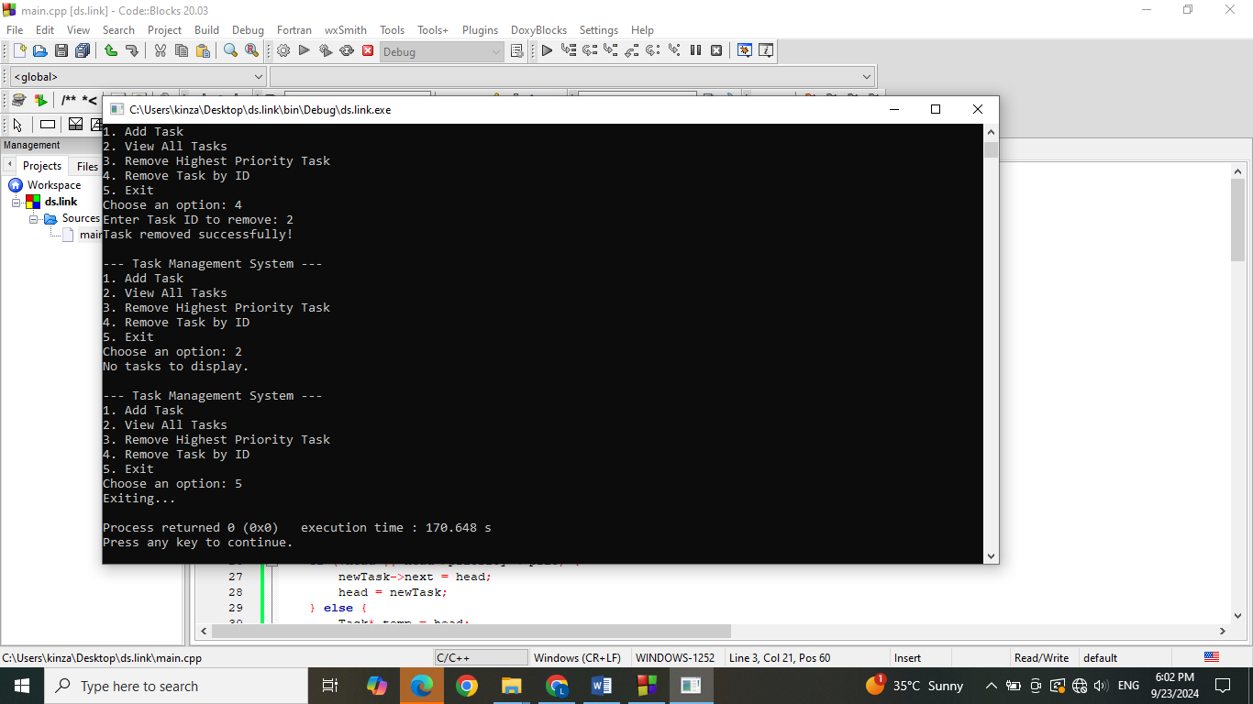

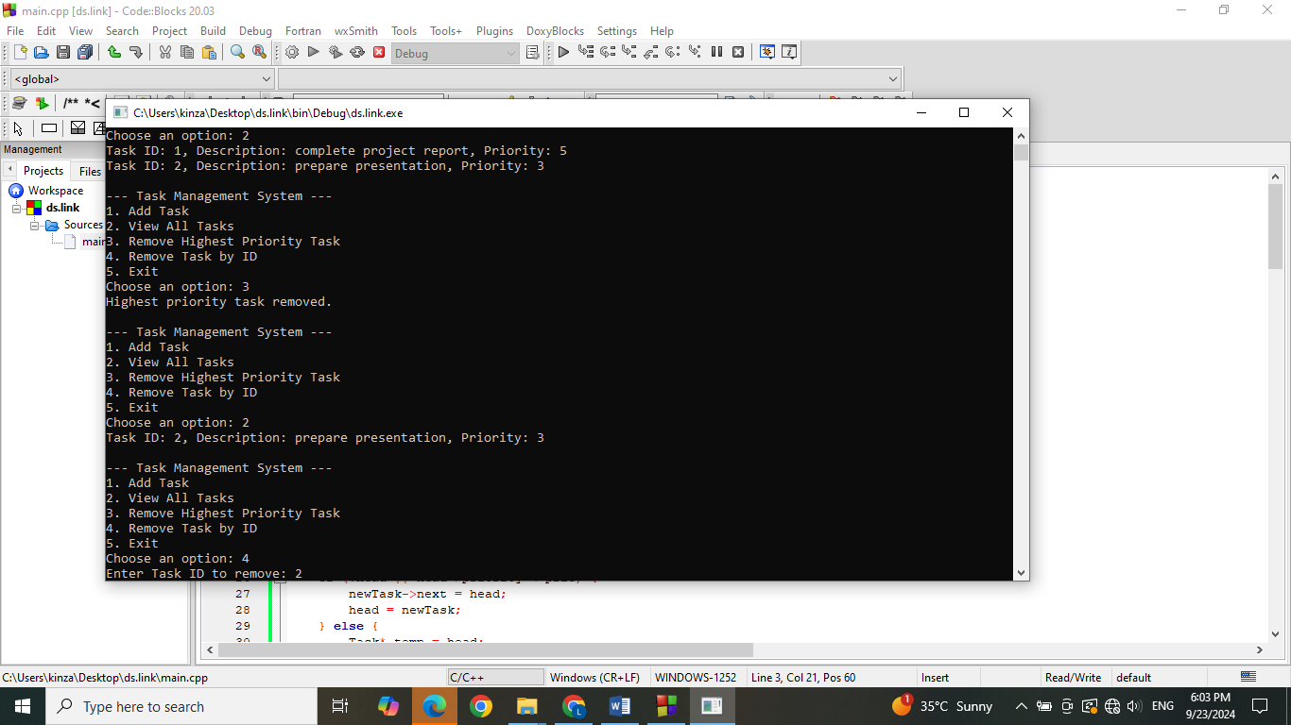

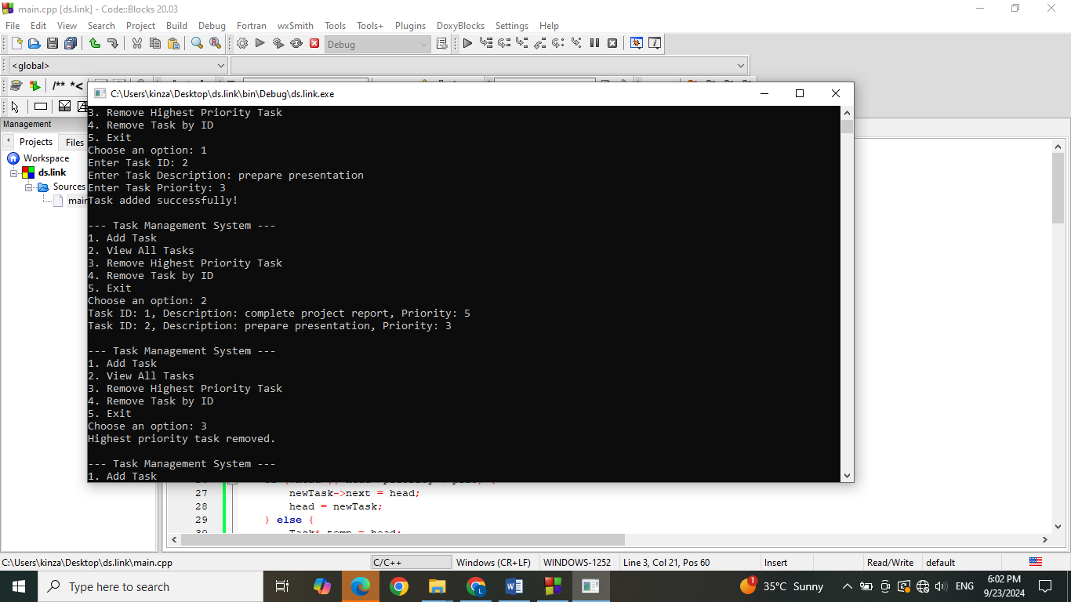

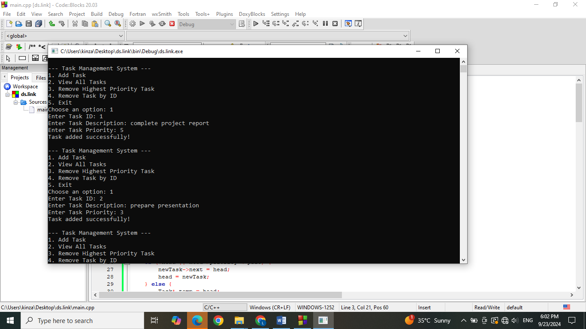

**3: Introduction:**

This management system using a singly linked list in C++. Each task is stored in a node with properties like ID, description, and priority. The system supports adding, viewing, and removing tasks based on their priority and ID.

**4:Code Explanation:**

**1:Fuction to implement:**

function in the code is designed to perform a specific task:

**2:CreateTask():**

Initializes a new task node.

**3:AddTask():**

Inserts a task based on its priority.

**4:RemoveHighestPriorityTask():**

Removes the task at the start of the list (highest priority).

**5:RemoveTaskByID**():

Removes a task by searching for its ID.

**6:ViewTasks**():

Displays all tasks in the list.Screenshots:Include screenshots of the program running different functionalities, such as adding a task, viewing tasks, and removing a task.

**5:Conclusion**:

In this assignment, I learned how to implement a singly linked list and manage operations like insertion, deletion, and traversal. One of the challenges was ensuring that tasks were inserted in the correct position based on their priority.